

Assignment

**Clothes Online System (COS)**

**Version: 1.0**

**Author: Nguyen Minh Quan**

– Hanoi, March 2024 –

# Record of Changes

| **Version** | **Date** | **A* M, D** | **In charge** | **Change Description** |
| --- | --- | --- | --- | --- |
| V1.0 | 13/2 | A | Quan | 1.1 Add the Actor |
| V1.0 | 13/2 | A | Quan | 1.1.a Add the UC Diagram |
| V1.0 | 13/2 | A | Quan | 1.1.b Add the b.description |
| V1.0 | 14/2 | A | Quan | 2.1 Draw the screen flow |
| V1.0 | 14/2 | A | Quan | 2.2 Add the screen description |
| V1.0 | 14/2 | A | Quan | 2.3 Add the screen authorization |
| V1.0 | 14/2 | A | Quan | 2.4 Add Non-UI Functions |
| V1.0 | 14/2 | A | Quan | 3.1.a Add the Database schema |
| V1.0 | 14/2 | A | Quan | 3.1.b Add the table description |
|  |  |  |  |  |
|  |  |  |  |  |
|  |  |  |  |  |

*A - Added M - Modified D - Deleted

Contents

Record of Changes 2

I. Overview 4

1. User Requirements 4

1.1 Actors 4

1.2 Use Cases 4

2. Overall Functionalities 5

2.1 Screens Flow 5

2.2 Screen Descriptions 5

2.3 Screen Authorization 5

2.4 Non-UI Functions 6

3. System High Level Design 6

3.1 Database Design 6

# I. Overview

## 1. User Requirements

### 1.1 Actors

| **#** | **Actor** | **Description** |
| --- | --- | --- |
| 1 | Admin | Manage order for Customers, user account, and product |
| 2 | Customer | View and buy the goods in online shop system |
| 3 | Guest | View the goods in online shop system |

#### a. UC Diagram

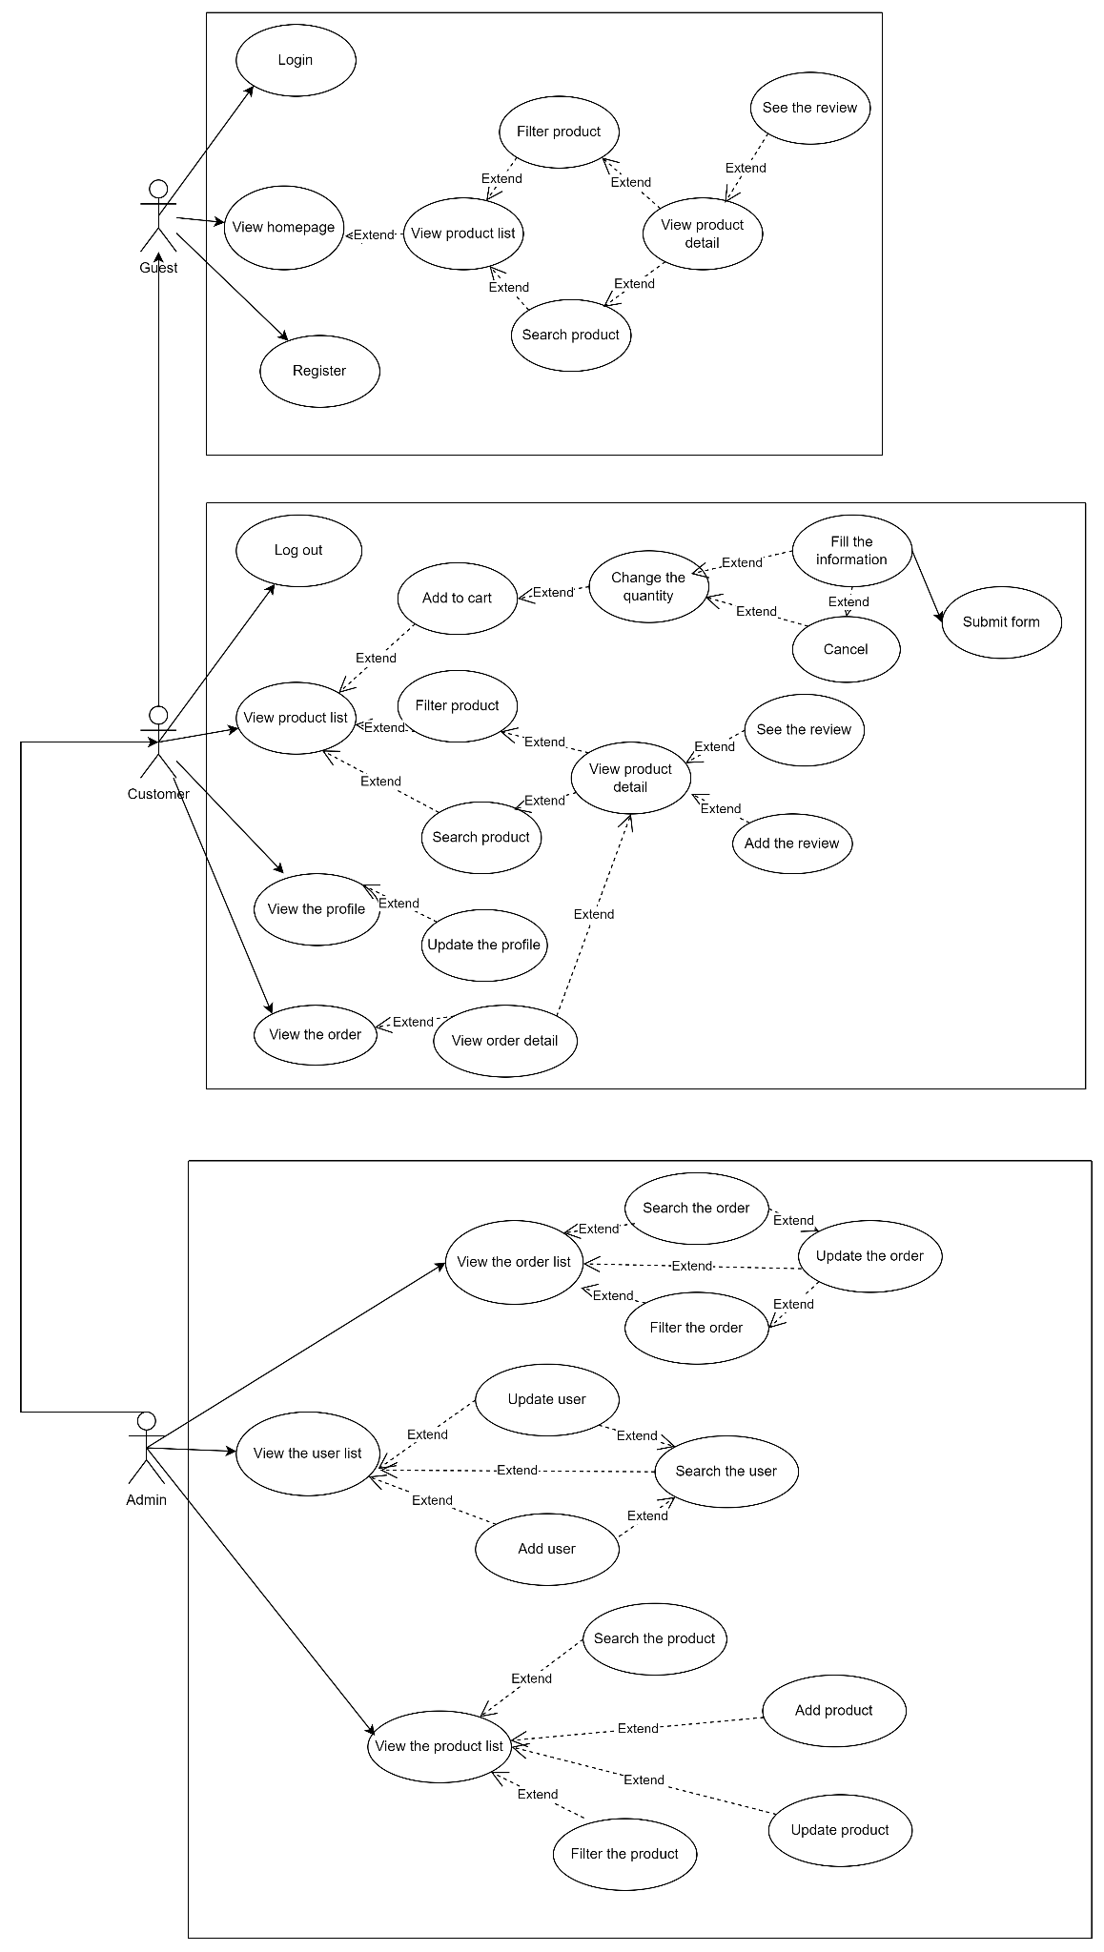

#### b. Descriptions

| **ID** | **Feature** | **Use Case** | **Use Case Description** |
| --- | --- | --- | --- |
| 01 | Homepage Operations | View Homepage | View the navbar(by role), productList, filter and search |
| 02 | Search Operation | Search product by name | View the product list by enter the name or part of name |
| 03 | Filter Operation | Filter product by category and brand | View the product list by tick the radio button in form include Category and Brand |
| 04 | Product Operation | View product list | View the product list in pagination |
| 05 | Product Operation | View product detail | View the detail of product |
| 06 | Cart Operation | Add to cart | Add a product from product list into a user cart |
| 07 | Cart Operation | Change the quantity | Increase the quantity of a product in user cart |
| 09 | Cart Operation | Remove the product | Remove a product from the user cart |
| 10 | Cart Operation | Check out the cart | Proceed product list in a cart to the check out page |
| 11 | Checkout Operation | Fill the user information | Fill the necessary user information to checkout product |
| 12 | Checkout Operation | Cancel the checkout | Cancel the checkout back to cart page to edit the quantity or remove product |
| 13 | Checkout Operation | Submit the checkout form | Submit the information user input, the product in the cart |
| 14 | Order Operation | View the order | View the orders of a users |
| 15 | Order Operation | View the order detail | See the product list in a order |
| 16 | Profile Operation | View the profile | See the user’s profile |
| 17 | Profile Operation | Edit the profile | Allow user edit profile in user’s profile view |
| 18 | Review feature | Add the review | Add a review in a product detail |
| 19 | Review feature | See the review | See the review list in a product detail |
| 20 | Product Management | Add a product | Add a new product into product list |
| 21 | Product Management | Update a product | Update a product exist in product list |
| 22 | Order Management | Update a order | Update the status of order |
| 23 | User Management | Update a user | Change the role of user,name of user |
| 24 | User Management | Add a user | Create a new user |
| 25 | Common feature | Login | Login the system with email and password |
| 26 | Common feature | Register | Register new account to the new system |
| 27 | Order Management | Search the order | Search the order by email of customer |
| 28 | User Management | Search the user | Search the user by email of customer |

## 2. Overall Functionalities

### 2.1 Screens Flow

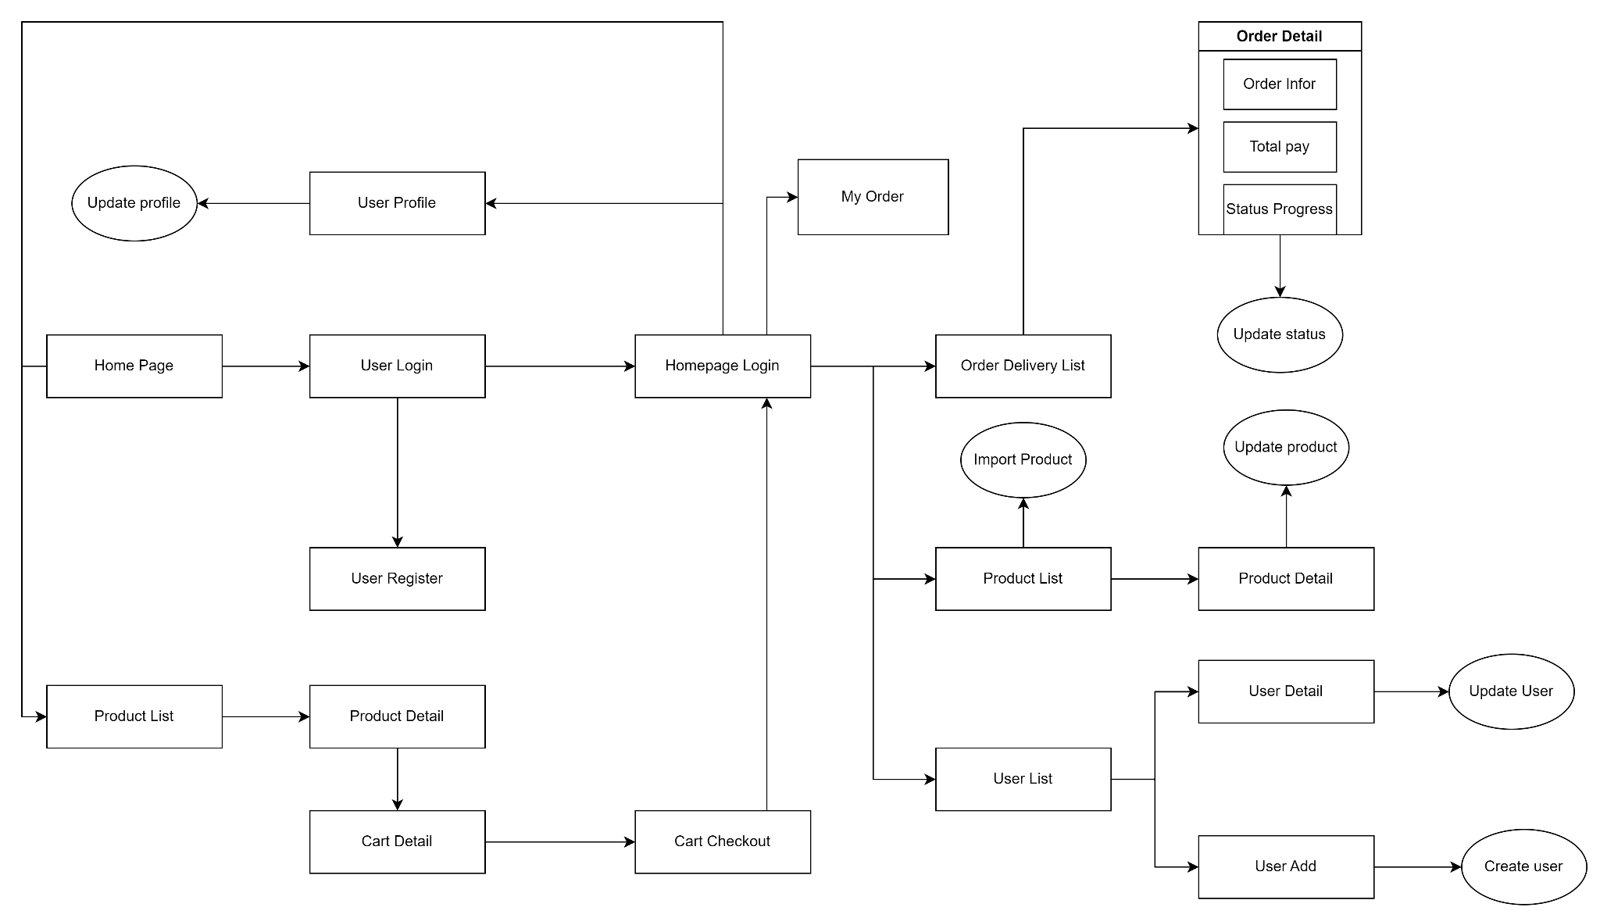

### 2.2 Screen Descriptions

| **#** | **Feature** | **Screen** | **Description** |
| --- | --- | --- | --- |
| 1 | Homepage Operation | HomePage | View the Homepage structure |
| 2 | Common feature | User Login | The screen for user login |
| 3 | Common feature | User Register | User register a new account |
| 4 | Product Operation | Product List | View the product in pagination with search and filter |
| 5 | Product Operation | Product Detail | View the detail of product, review of product |
| 6 | Cart Operation | Cart Detail | View the product in the user cart |
| 7 | Checkout Operation | Cart Checkout | View the cart product list and the information of user |
| 9 | Homepage Operation | Homepage login | View the feature homepage by role in the system |
| 10 | Profile Operation | User profile | View the profile user |
| 11 | Order Operation | My Order | View the user’s order |
| 12 | Order Management | Order Delivery List | View the order of all user in system |
| 13 | Order Detail | Order Detail | View the detail order in the Order Delivery List screen |
| 14 | Product Management | Product List | View the product list with filter and search |
| 15 | Product Management | Product Detail | View the detail of product include the ID of product |
| 16 | User Management | User List | View the user list in the system |
| 17 | User Management | User Detail | View the user detail |
| 18 | User Management | User Add | Add a user into the system |

### 2.3 Screen Authorization

| **Screen** | **Guest** | **Customer** | **Admin** |
| --- | --- | --- | --- |
| HomePage | X | x | X |
| User Login | x |  |  |
| User Register | X |  |  |
| Product List | X | x | x |
| Product Detail | x | x | X |
| Cart Detail |  | x | X |
| Cart Checkout |  | x | X |
| Homepage login |  | x | x |
| User profile |  | x |  |
| My Order |  | x | x |
| Order Delivery List |  |  | x |
| Order Detail |  |  | x |
| Product List |  |  | x |
| Product Detail |  |  | x |
| User List |  |  | x |
| User Add |  |  | x |
| User Detail |  |  | x |

### 2.4 Non-UI Functions

| **#** | **Feature** | **System Function** | **Description** |
| --- | --- | --- | --- |
| 1 | Validation | Validation users | Prevent guest use the function of admin and user |
| 2 | Validation | Validation admin | Prevent who the role not the admin use the admin function |

## 3. System High Level Design

### 3.1 Database Design

#### a. Database Schema

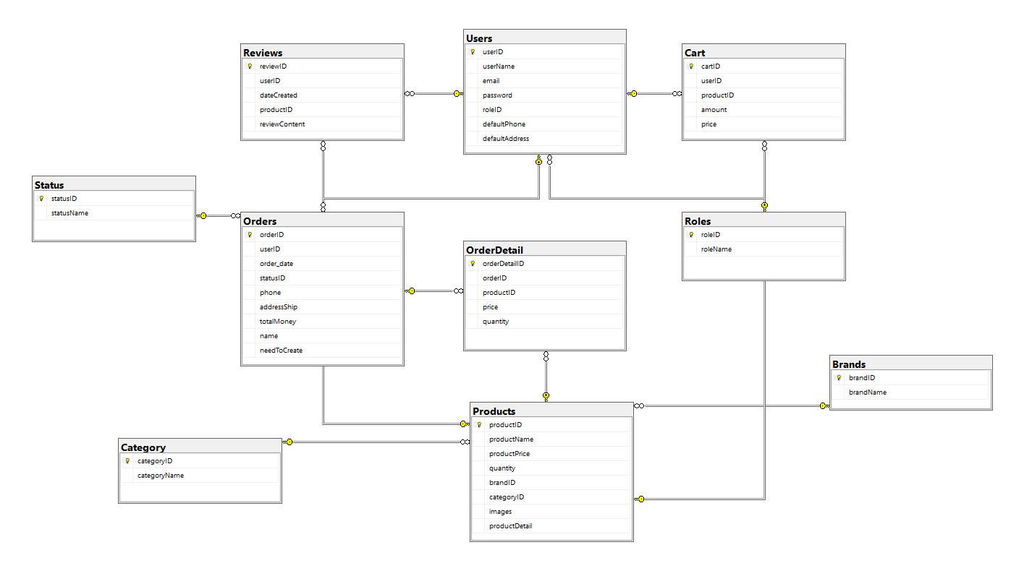

#### b. Table Descriptions

| **No** | **Table** | **Description** |
| --- | --- | --- |
| 01 | Users | **Store the user account in the system**  - Primary keys: userID  - Foreign keys: roleID |
| 02 | Cart | **Store the product user choose into cart**  - Primary keys: cartID  - Foreign keys: userID,productID |
| 03 | Roles | **Store the role in the system**  **-** Primary key: roleID |
| 04 | Reviews | **Store the review of product**  **-** Primary key: reviewID  - Foreign key: userID,productID |
| 05 | Orders | **Store the user orders**  **-** Primary key: orderID  -Foreign key: statusID,userID |
| 06 | Order detail | **Store the product list in a order**  **-** Primary key: orderDetailID  - Foreign key: orderID,productID |
| 07 | Status | **Store the status of order**  **-** Primary key: statusID |
| 08 | Products | **Store the product in system**  **-** Primary key: productID  - Foreign key: brandID,categoryID |
| 09 | Category | **Store the category list of product**  **-** Primary key: categoryID |
| 10 | Brand | **Store the brand list of product**  **-** Primary key: brandID |

## 